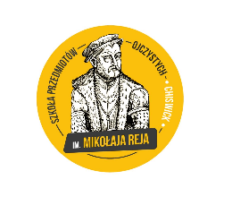
Ladies and Gentlemen,

The M. Rej Polish Language School has been working with St. Andrew Bobola Parish since its inception in 1961. The parish is not only an important center of Polish religious and national life, but also a social center. For many people, especially the elderly, the parish is a meeting place, where support and kind words always await.
During the pandemic it did not suspend its activity, but worked with increased energy. The pastor of the parish, Fr. Marek Reczek, who is also a catechist at our school, has made every effort to meet the challenges of the difficult times in which we live by constantly adapting his pastoral ministry.
On Sunday, May 16, we celebrated the Feast of the Patron Saint A. Bobola. I would like to take this opportunity to appeal to you to make a financial contribution - a free gift - to the parish with which the school has been associated for so many years. On Saturday, May 22nd, the class teachers will be treating the children with bobolinks (also allergy cookies) baked by the teachers. It would be good for the children to bring some money which they can throw into the collection box. All funds raised will be donated to the parish priest to help the elderly associated with the parish.

We thank you in advance for your support of this initiative and encourage you to visit the parish website.
Sincerely yours
The Management Board of the Mikolaj Rej Polish School

